**Unit 1. Differentiation and its Applications**

**Practise Questions**

1. On a sunny day, a 50 ft flagpole casts a shadow that changes with the angle of elevation of the Sun. Let ‘s’ be the length of the shadow and ‘θ’ the angle of elevation of the Sun. Find the rate at which the length of the shadow is changing with respect to θ when θ = 45◦ . Express your answer in units of feet/degree.

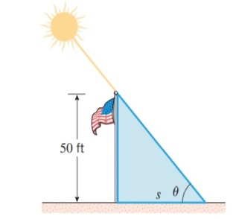

1. An airplane is flying on a horizontal path at a height of $3800$ ft, asshown in the accompanying figure. At what rate is the distance s between the airplane and the fixed point P changing with respect to θ when θ = 30◦ ? Express the answer in units of feet/degree

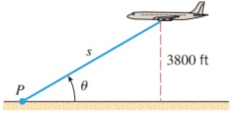

1. A mass on a spring vibrates horizontally on a smooth level surface . Its equation of motion is $x=8cost$, where t is in seconds and $x$ in centimeters. (a) Find the velocity and acceleration at time t. (b) Find the position, velocity, and acceleration of the mass at time $2π/3$. In what direction is it moving at that time?

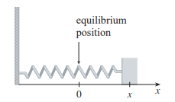

1. If $x^{2}+y^{2}=25$ then (a) find $\frac{dy}{dx}$ (b) Find an equation of tangent line to the circle $x^{2}+y^{2}=25$ at the point (3 , 4).
2. If $x^{3}+y^{3}=6xy$ then find(a) $\frac{dy}{dx} (b)$ Find an equation of tangent line to the circle ${ x}^{3}+y^{3}=6xy$ at the point $(3,3)$.
3. A ladder 10 ft long rests against a vertical wall. If the bottom of the ladder slides away from the wall at a rate of 1 ft/s, how fast is the top of the ladder sliding down the wall when the bottom of the ladder is 6 ft from the wall?

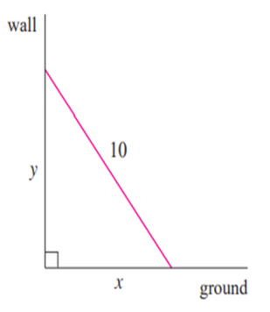

1. A man walks along a straight path at a speed of 1.5m/s. A searchlight is located on the ground 6m from the path and is kept focused on the man. At what rate is the searchlight rotating when the man is 8m from the point on the path closest to the searchlight?

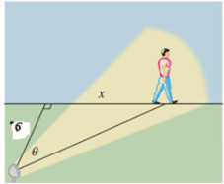

1. Two cars start moving from the same point. One travels south at 60 km/hr and the other travels west at 25 km/hr. At what rate is the distance between the cars increasing two hours later?
2. A hot air balloon rising straight up from a level field is tracked by a range finder 500 feet from the liftoff point. At the moment the range finder’s elevation angle is $π/4$, the angle is increasing at the rate of 0.14 rad /min. How fast is the balloon rising at that moment?
3. Find the local maximum and minimum value of f(x)= 2x3 - 15x2 +36x on the interval [1,5].
4. An open-top box is to be made by cutting small congruent squares from the corners of a 12-inch.by 12-inch. sheet of tin and bending up the sides. How large should the squares cut from the corners be to make the box hold as much as possible?

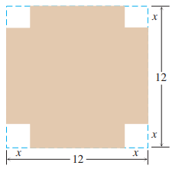

1. A farmer has 1200 meter of fencing and wants to fence off a rectangular field that borders a straight river. He needs no fence along the river. What are the dimensions of the field that has the largest area?
2. Verify Rolle’s theorem for the function $f\left(x\right)=x^{2}-5x+4$ for every x in [1,4]
3. Verify Rolle’s theorem for the function $f\left(x\right)=e^{x}sinx$ for every x in [0,π]
4. Verify Lagrange’s mean value theorem for the function $f\left(x\right)=x\left(x-1\right)(x-2)$ for every x in [0,0.5]
5. Verify Lagrange’s mean value theorem for the function $f\left(x\right)=\sqrt{x-2}$ for every x in [2,3]
6. Find the nth derivative of $f\left(x\right)= cosx cos2x cos3x$
7. Find the nth derivative of = sin3 x cos2 x.
8. Expand $f\left(x\right)$ = $\tan^{-1}x$ in the powers of $\left(x-1\right)$ $.$
9. Expand $f(x)$ = $\sin{x}$ in the powers of $(x- \frac{π}{4})$.
10. Prove that: log(1+ $e^{x}$) = log2 $-\frac{x}{2}+\frac{x^{2}}{8}-…$
11. Prove that: log(1+sinx)= $x-\frac{x^{2}}{2!}- \frac{x^{3}}{3!}-$...
12. (a)Find the local linear approximation of f (x) = $\sqrt{x+3}$ at a = 1.

(b) Use the local linear approximation obtained in part (a) to approximate √3.98, and compare your approximation to the result produced directly by a calculating utility.

1. The radius of a sphere was measured and found to be 21 cm with a possible error in measurement of at most 0.05 cm. What is the maximum error in using this value of the radius to compute the volume of the sphere?
2. Use differentials to estimate the amount of paint needed to apply a coat of paint 0.05 cm thick to a hemispherical dome with diameter 50 cm.